**Linear Search: (GCSE & A-Level)**

The Linear Search starts at the beginning item in the list and checks each item one by one until it finds the intended search term.

*Simplified Explanation:*

1. Start at the first item in the list.
2. If this item is the search term, then the search is complete.
3. If the item is not the search term, then move to the next item in the list.
4. Repeat Step 2 until the search term is found or when there are no more items in the list.

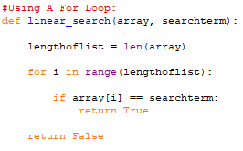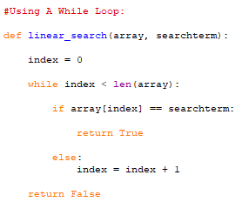**Linear Search in Python:**

|  |  |
| --- | --- |
| **Advantages:** | **Disadvantages:** |
| * Effective finding item in small data sets (Lists) | * Slowest type of search. Inefficient. |
| * Can be used on any list (sorted or unsorted) | * Number of operations/loops can vary depending on the size of the data set (list) |
| * Easy to program and easy to implement |  |

**Big O Notation of Linear Search (A-Level):**

|  |  |  |
| --- | --- | --- |
| **Best Case** | **Average Case:** | **Worst Case** |
| * Constant | * Linear | * Linear |
| * O(1) | * O(n) | * O(n) |

**Recursive Linear Search: (A-Level)**

